**Transcriptomic Analysis of Respiratory Center of Duchenne Muscular Dystrophy Mice Model**

**Abstract:**

Duchenne muscular dystrophy (DMD) is a devastating X linked genetic disorder caused by a lack of the dystrophin protein due to mutations in the *DMD* gene. DMD patients experience progressive respiratory insufficiency and succumb to respiratory failure. Respiratory insufficiency in DMD is credited to muscle pathology.  However, the impact of dystrophin deficiency in the respiratory centers located in the central nervous system is unknown. Previously, ElMallah lab reported axonopathies in the hypoglossal (XII) and phrenic nerves of *mdx* (dystrophin null) mice-a mouse model for DMD. These respiratory nerves originate from the motoneurons in the medulla and cervical spinal cord and innervate the tongue and diaphragm, respectively, to regulate upper airway patency and breathing. In this study, we will perform transcriptomic analysis of the medulla and cervical spinal cord of wild-type (*WT*) and *mdx* mice at different age groups p8, 6 months and 12 months. We will perform analysis using the Bioconductor package in R to perform a differential expression analysis. The transcriptomic analysis of the medulla and cervical spinal cord will provide us with information about significant differences in the expression of several genes necessary for the development, survival, and functioning of glial cells and neurons in the *WT* and *mdx* mice at different age groups. These findings may provide new insights into respiratory and motor complications in DMD and identify potential therapeutic targets for these problems.

**Introduction:**

Duchenne Muscular Dystrophy (DMD) is a muscular disease found in youth due to an X linked mutation in the dystrophin gene and in 4 sarcoglycan genes (Mercuri et al., 2019). These mutations lead to a lack of functional dystrophin and may lead to the loss of glycoproteins, causing the pathogenesis of muscular dystrophy molecularly (Ervasti et al., 1990). DMD is a fatal condition with median survival of around 35 years (Kohler et al., 2009). Respiratory failure is the most common cause of death due to DMD (Baydun et al., 1990). Myopathies like DMD commonly have the consequence of muscular failure due to either or both lung failure and pump failure as a direct result of the lack of dystrophin (Mauro & Aliverti, 2016).

The most common mouse model of DMD is the *mdx* mouse in which exon 23 of the dystrophin gene exhibits loss of function similar to a DMD patient due to a point mutation (Sicinski et al., 1989). Previously, ElMallah Lab identified axonopathies in the phrenic and hypoglossal (XII) nerves in *mdx* mice when compared to wild-type (WT) (Dhindsa et al., 2020). The phrenic nerve connects the C3 to C5 cervical to the spinal cord (Davis, 1967). The XII Cranial nerve, the hypoglossal nerve, is connected from the medulla to the tongue to provide motor innervation (Lin & Barkhaus, 2009).

In this study, we isolated tissues from *mdx* and wild-type (WT) mice’s medulla and cervical spinal cord to perform a transcriptomic analysis. To perform this analysis, we used the DESeq2 (Love et al., 2023) package in R. We analyzed samples in p8, 6 months, and 12 months age groups to further find if the expression of the mRNA changes as the mouse ages. The data we present could elucidate potential gene expression causes for respiratory failure, building upon previous linking between these tissues and respiratory failure in *mdx* mice (Dhindsa et al., 2020).

**Materials and Methods:**

**Animals:**

All mice were approved by the Duke University Institutional Animal Care and Use Committee (IACUC). All experiments were performed with respect to relevant guidelines and regulations. Wildtype (WT) and C57Bl/10ScSn-Dmd*mdx*/J (*mdx*), mice were obtained from the Jackson Laboratory and housed at the Duke University Division Laboratory Animal Resources. Only WT and *mdx* mice were used in this study (Table 1).

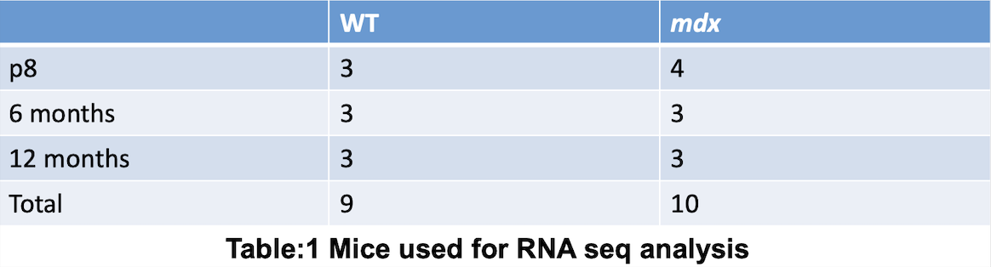

**RNA-Sequencing, Differential Expression, and Gene Ontology Enrichment Analysis**

The RNA was prepared for sequencing using the Kapa Stranded mRNA-seq Library prep kit following the manufacturer’s protocol. Sequencing was performed on a Illumina NovaSeq 6000 with 50 bp paired-end reads. Quality control on the sequencing data was completed with FastQC 0.11.5. Sequences were aligned to the Grc38 (mm10) reference genome and gene expression values were created using STAR 2.7.2 by setting --quantMode to GeneCounts. DESeq2 (version 1.38.3) in R (version 4.2.3) was used for the differential expression analysis. All data was normalized on a per tissue basis (e.g. medulla data was normalized with only medulla data). Variance stabilizing transformation was applied to the gene expression matrix to produce heatmaps of data. Cutoff values of a false discovery rate of less than 0.1 and absolute fold change greater than 2 were used to select differentially expressed genes between groups. Over-representation analysis was completed using the clusterProfiler R package (version 3.18.1). Gene ontology enrichment analysis was performed using Bioconductor’s genome wide annotation for a mouse (version 3.16). Only values with a p-value less than 0.05 were included as significant.

**Results:**

**There is general separation in gene expression between *mdx* and WT mice found using principal component analysis (PCA).**

First, we performed PCA to visualize if the genes from different genotypes at different age group exhibit a trend to cluster together or seperately. Generally, in Fig.1 there is clear separation at all age groups between the WT and *mdx* mice. This is indicative that there is likely some difference in the gene expression in both the medulla and cervical spinal cord of WT and *mdx* mice, encouraging further statistical analyses. From p8 to 12 month, in both tissues, the amount of separation between WT and *mdx* mice decreases as the mice ages. For example, in the 12 month medulla WT and *mdx* mice comparison, there was the smallest difference between the two clusters.

***ND3* and *Gm16867* genes are found to be statistically different in regulation in all age groups in WT vs. *mdx* mice comparison using volcano plots.**

Next, we analyzed the data using volcano plots to enable quick visual identification of genes with large fold changes that are the most significantly different between *mdx*  and WT mice. In Fig. 2, we get a good read on what genes are likely most responsible for differing biological processes that are observed. In all of these plots, *ND3* (Electron transport chain regulation (Jin et al., 2018))and *Gm16867* (protein coding (*Gm16867 Predicted Gene, 16867 [Mus Musculus (House Mouse)] - Gene - NCBI*, n.d.)) stood out as statistically significant.

There is also difference within age groups of the same tissue of WT and *mdx* mice. Fig. 2. A. represents the statistical differences between p8 medulla of WT and *mdx* mice genes. We found that *Gh (Growth hormone)* and *Gm3521* (angiogenesis inhibitor (*Mgp Matrix Gla Protein [Mus Musculus (House Mouse)] - Gene - NCBI*, n.d.)) are statistically different; however, the expression of these genes is not significant in the plot for gene expression of medulla from 6-months old WT vs. *mdx* mice (Fig. 2. B.) and in the plot for gene expression of medulla of 12-months old WT and *mdx* mice (Fig. 2. C). Although the volcano plots for the cervical spinal cord plot were different overall than for the medulla, there are some similarities. For example, the expression of *Gm3521* is also seen only in the p8 cervical spinal cord plots (Fig. 2. D.) and not in the volcano plot for gene expression of medulla from 6- and 12-month old WT and mdx mice (Fig. 2. E and F) alike to the trend witnessed in the medulla.

**Gene ontology enrichment shows disruption of myelin sheath development and protein folding pathways in the mdx medulla tissue.**

Fig. 3 is a graphical representation of the gene ontology enrichment analysis of the RNA Sequencing data. There are three categories of information that this analysis gives us: differences in biological processes (BP), molecular function (MF), and cellular components (CC). In the medulla tissue there were statistically significant (p < 0.05) differences in the p8 (Fig. 3. A) and 6-month (Fig. 3. B) age groups between the WT and *mdx* mice. Both the p8 and 6 month medulla *mdx* mice showed demyelination and dysregulation in protein folding.

However, there were no significant differences found in the 12-month (Fig. 3. C) age group. More research upon a larger dataset needs to be done to confirm if this finding is generalizable.

**Gene ontology analysis shows dysregulation in protein synthesis in the *mdx* cervical spinal cord tissue.**

Fig. 3. D, E, F show the gene ontology results of the different age groups (p8, 6-month, 12 month) of the cervical spinal cord tissue from WT and *mdx* mice. Overall, the *mdx* mice presents dysregulation in protein synthesis. The p8 *mdx* cervical spinal cord tissue (Fig. 3 D) showed differential expression of genes that can contribute to defective ribosomal activity in *mdx* mice, notably in the large ribosomal unit (involved in translation). In addition, in 6-month *mdx* mice (Fig. 3 E), we observe dysregulation of genes that contribute to weakened microtubule cytoskeletons, and in 12-month *mdx* cervical spinal cord tissue (Fig. 3 F) we see a lack of chaperone proteins in the endoplasmic reticulum’s protein complex. Overall, these data indicate the cervical spinal cord from *mdx* mice has impaired protein translation machinery as well as has a dysfunctional cytoskeleton.

**Heatmaps from WT and *mdx* mice medulla and cervical spinal cord shows top (number) differentially expressed genes.**

Fig. 4 presents heatmaps of differentially expressed genes in WT and *mdx* mice at different age groups. This data supports the findings from the other plots. In p8 cervical spinal cord (Fig. 4 D.) and 12-month cervical spinal cord (Fig. 4 F), we found consistent downregulation of the *Nd3*  gene in *mdx* mice and upregulation in ­WT mice. This supports the finding that *Nd3* was one of the most significant genes for the differences between the two genotypes similar to what we found in Fig.2. As mentioned earlier, expression of the *Nd3* gene regulates the electron transport chain (Jin et al., 2018). Other energy producing pathways are likely affected tangentially in *mdx* mice. Another gene *Gh* is more down regulated in the medulla *mdx* tissue than in the respective WT tissue similar to what we observed in volcano plot.

The heatmaps also reveal certain genes that are significant among a few sample but not as whole. For example, expression of *Ttr* gene (vitamin A transport (*TTR Transthyretin [Homo Sapiens (Human)] - Gene - NCBI*, n.d.)) was varied greatly in 6-month medulla *mdx* mice (Fig. 4B): one out of three *mdx* mouse presented over 4-fold upregulation, whereas another presented around 2-fold downregulation compared to WT.

Two of the 12-month *mdx* medulla tissue (Fig.4C) show similar down regulation in most of the genes present; in contrast, one of the mdx samples presents an upregulation in most of the genes. This could likely explain the lack of significant gene ontology results for the 12-month medulla *mdx* vs. WT mice comparison. However, we cannot deduce whether this sample is an outlier definitively due to our small sample size.

These genes require further independent study and discussion, as they exhibit different properties in different mice samples within the same age groups.

**Discussion:**

In this study, we show changes in the differentially regulated pathways in *mdx* mice among different age groups in their medulla and cervical spinal cord tissue. Even at p8, there is clear difference in the variance of gene expression in *mdx* and WT mice. This continues to hold as the mouse ages to 12 months. There are a few outliers and intricacies to the data that encourage further data collection and wet lab support, such as the lack of significant gene ontology results for the 12-month medulla *mdx* vs. WT mice comparison. Overall, a few genes stand out as the most significant for the symptoms presented in *mdx* mice: *Nd3 and Gm16867.* The *Nd3* gene has a pathway of the electron transport chain (Jin et al., 2018) and *Gm16867* generally has a pathway of protein coding in the literature (*Gm16867 Predicted Gene, 16867 [Mus Musculus (House Mouse)] - Gene - NCBI*, n.d.); however, it is orthologous to the human gene *SLC25A37* which has a pathway of mitochondrial heme synthesis (*SLC25A37 Solute Carrier Family 25 Member 37 [Homo Sapiens (Human)] - Gene - NCBI*, n.d.), indicating that this gene also is directly related to cellular production of ATP (Jonckheere et al., 2012). Lack of ATP production is in line with the reported symptoms of young patients of DMD, as one of the most common ones is fatigue (Pangalila et al., 2015).

In addition to that, the transcriptomic analysis supports the previous finding of the ElMallah Lab where axonopathies in the phrenic and hypoglossal (XII) nerves of *mdx* mice when compared to WT mice (Dhindsa et al., 2020). For example, gene ontology analysis presented demyelination in p8 and 6-month *mdx* medulla tissue. Finding these deficiencies in the medulla and cervical spinal cord (respiratory centers) gives insight to the potential reasons behind the most common cause of mortality in patients suffering from DMD: respiratory failure (Baydun et al., 1990).

Further wet lab research must be done to confirm these statistical findings. These findings elucidate certain genes that are responsible for symptoms found in *mdx* mice.

**Figures:**

**Figure 1. Principal Component Analysis of WT and *mdx* mice in different age groups.**

Principal component analysis after variance stabilizing transformation of the matrix for overall gene expression of (A) p8 medulla, (B) 6 month medulla, (C) 12 month medulla, (D) p8 cervical spinal cord, (E) 6 month cervical spinal cord, (F) 12 month cervical spinal cord of wild type (n = 9) and *mdx*(n = 10). Clustering indicates similarity. In general, for p8, 6 month, and 12 month medulla (A, B, C) the *mdx* mice are more spread out and the WT mice are more clustered. This pattern is seen greater in all age groups of the cervical spinal cord (D, E, F) where the *mdx* mice and the WT mice are separated from each other. This indicates that there is likely difference in gene expression in the medulla and cervical spinal cord mice of WT and *mdx* mice, encouraging further statistical analysis.

**Figure 2. Volcano Plots of WT and *mdx* mice different age groups.**

Volcano plots after variance stabilizing transformation of the matrix for overall gene expression and differential expression analysis of (A) p8 medulla, (B) 6 month medulla, (C) 12 month medulla, (D) p8 cervical spinal cord, (E) 6 month cervical spinal cord, (F) 12 month cervical spinal cord of wild type (n = 9) and *mdx*(n = 10). The plots visualize the genes with the largest log2FoldChange that are significant (p<0.05). In essence, they could hint at the genes most responsible for resulting symptoms. Two genes in particular stand out: *Nd3* and *Gm16867*. They are both present in all 6 age groups of (A, B, C, D, E, F).

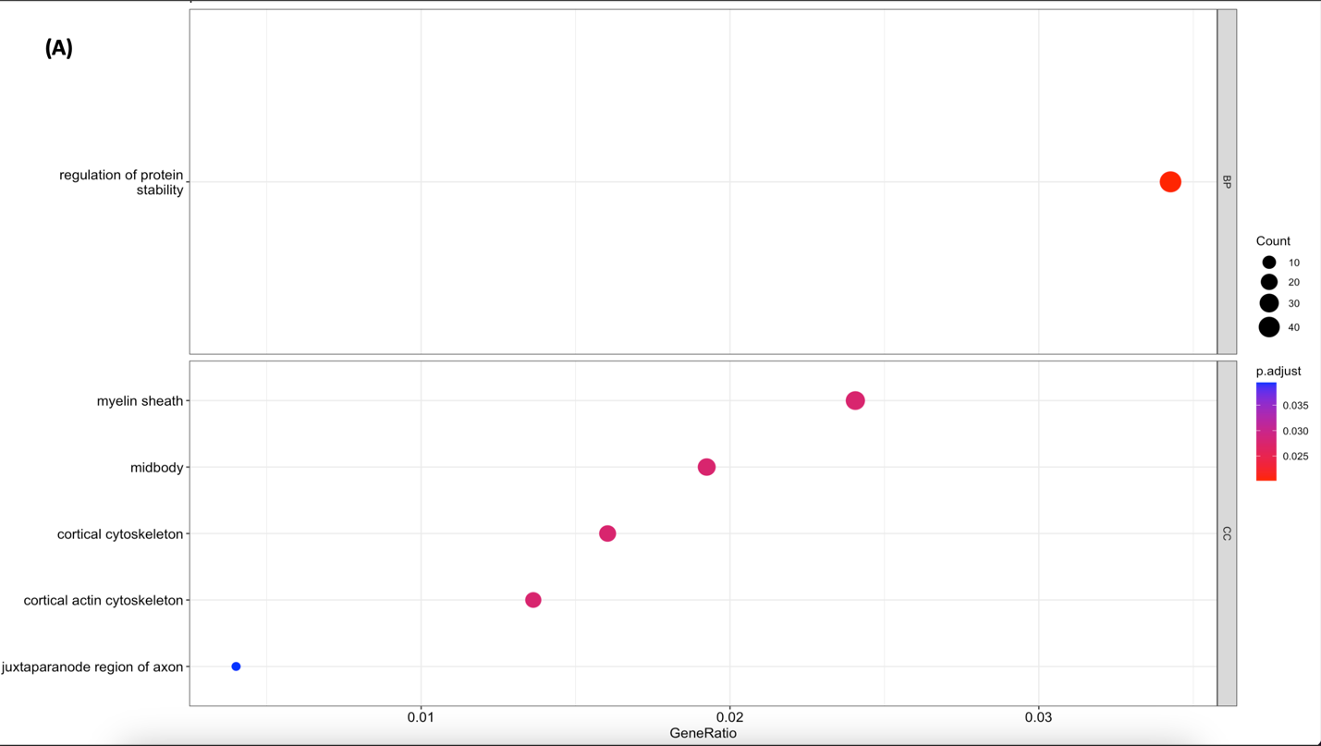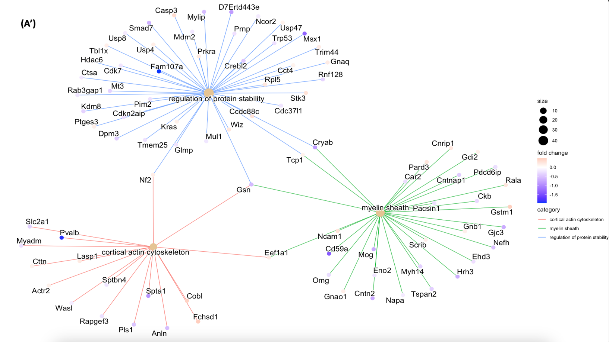

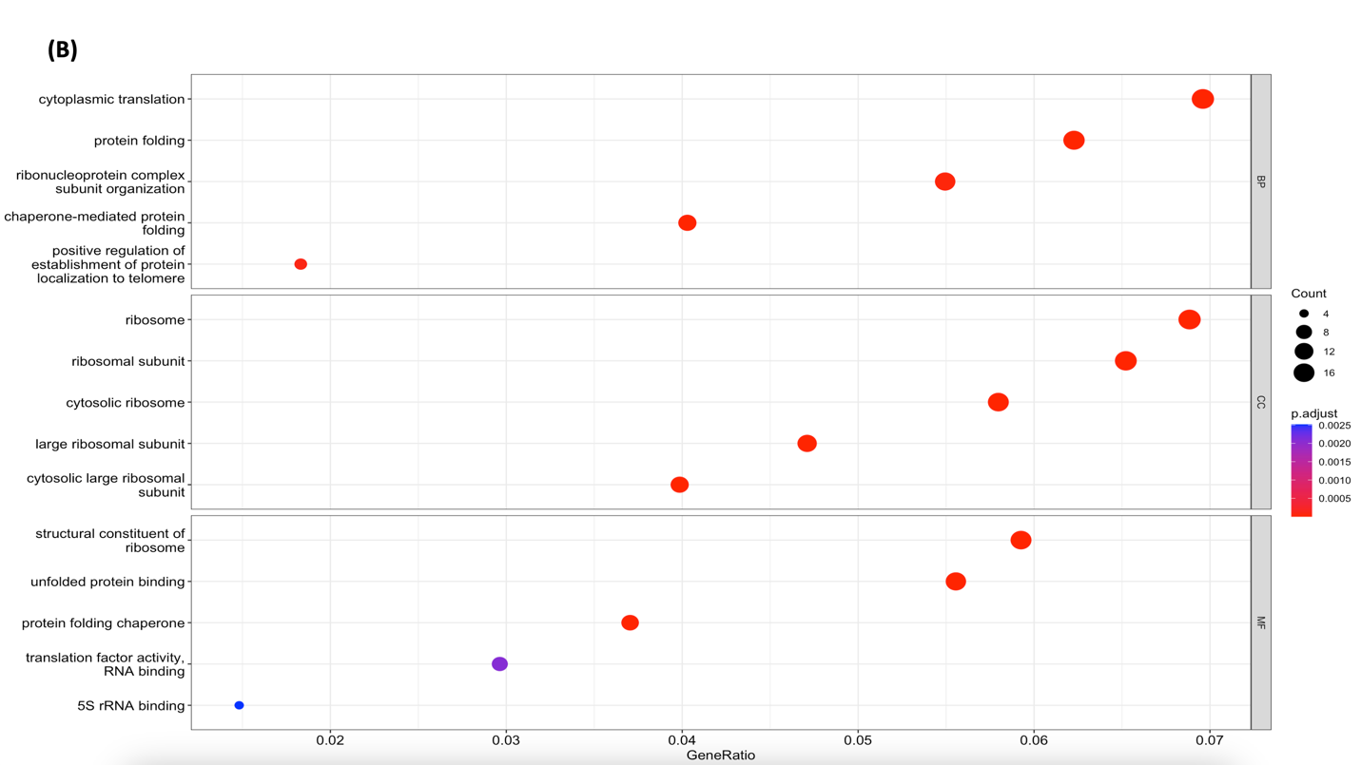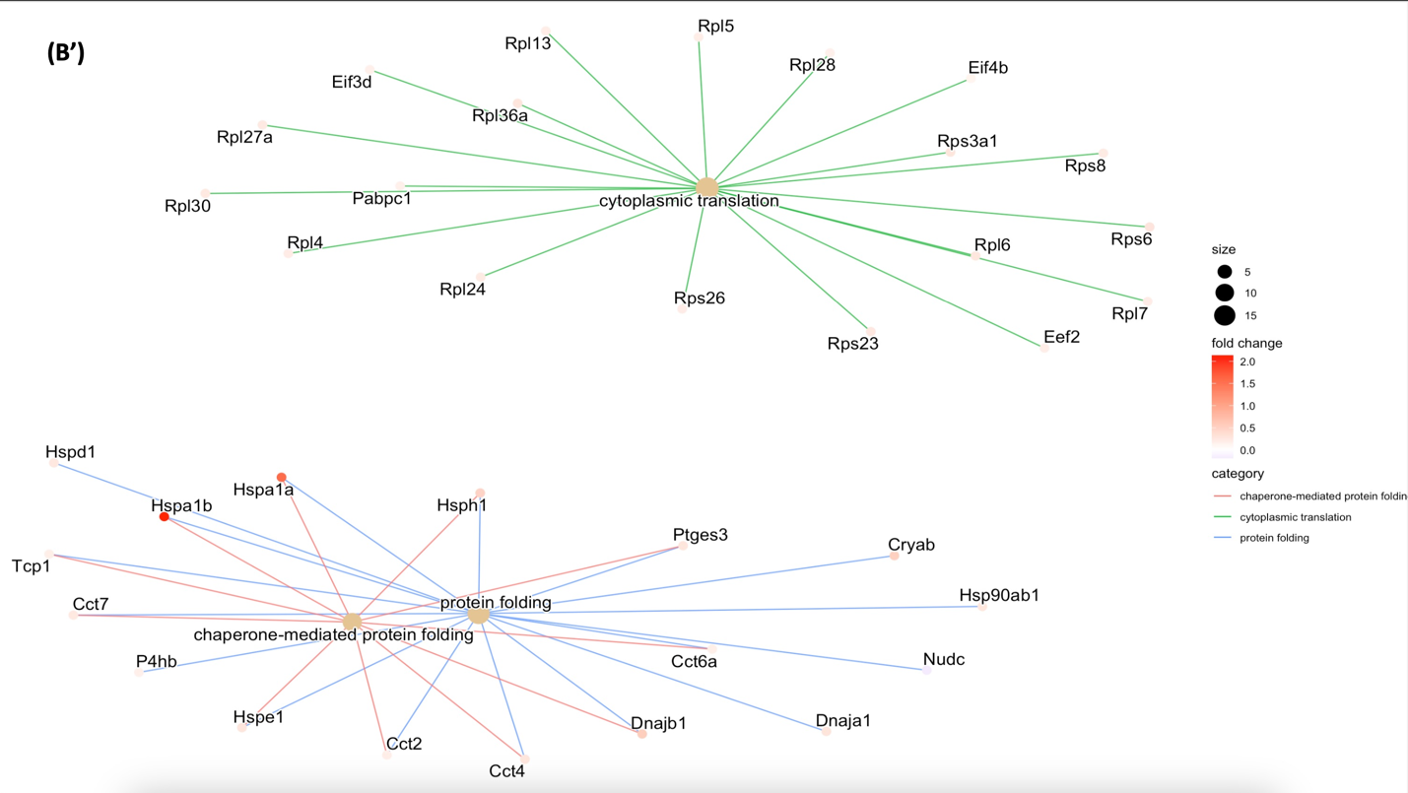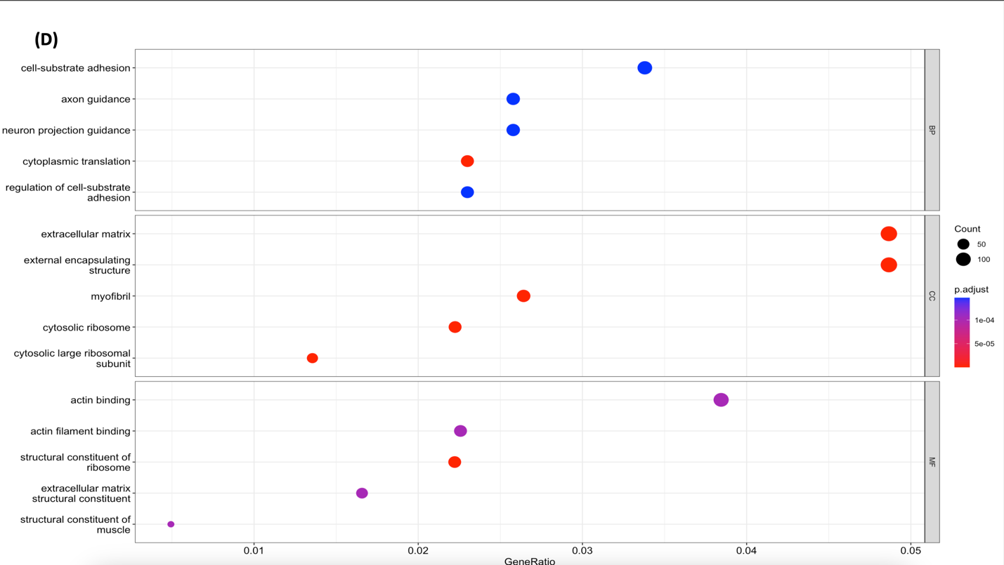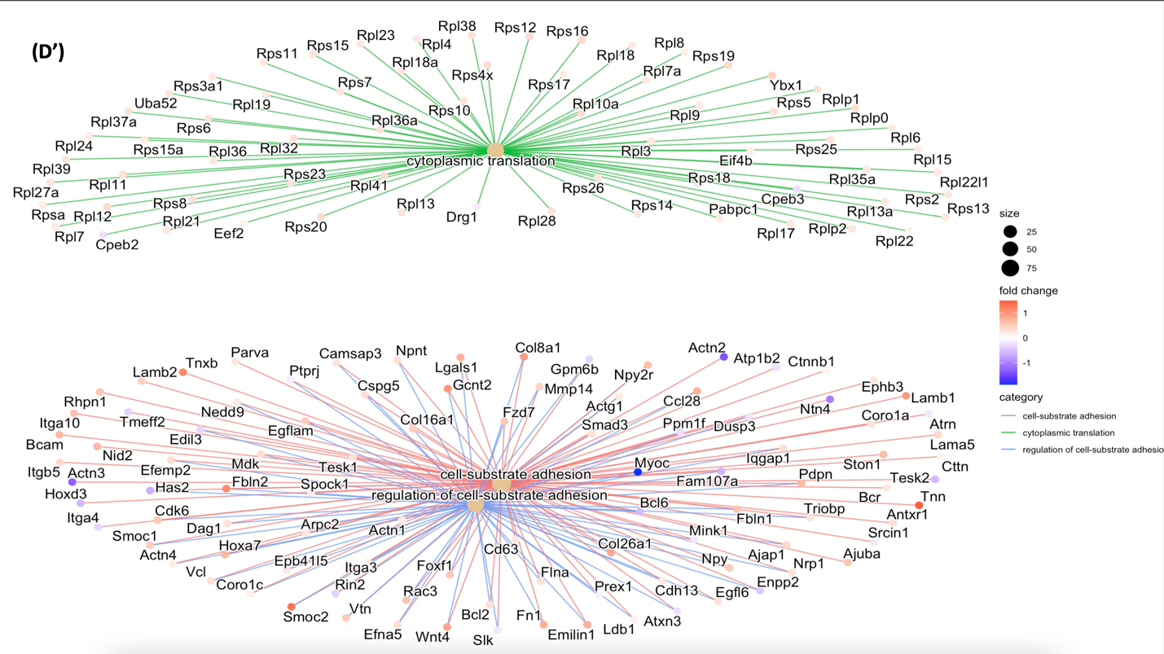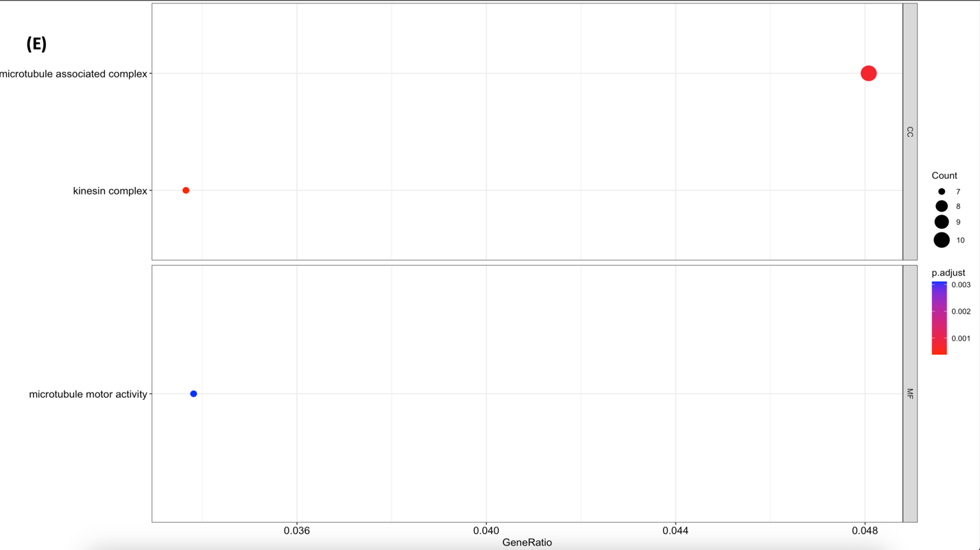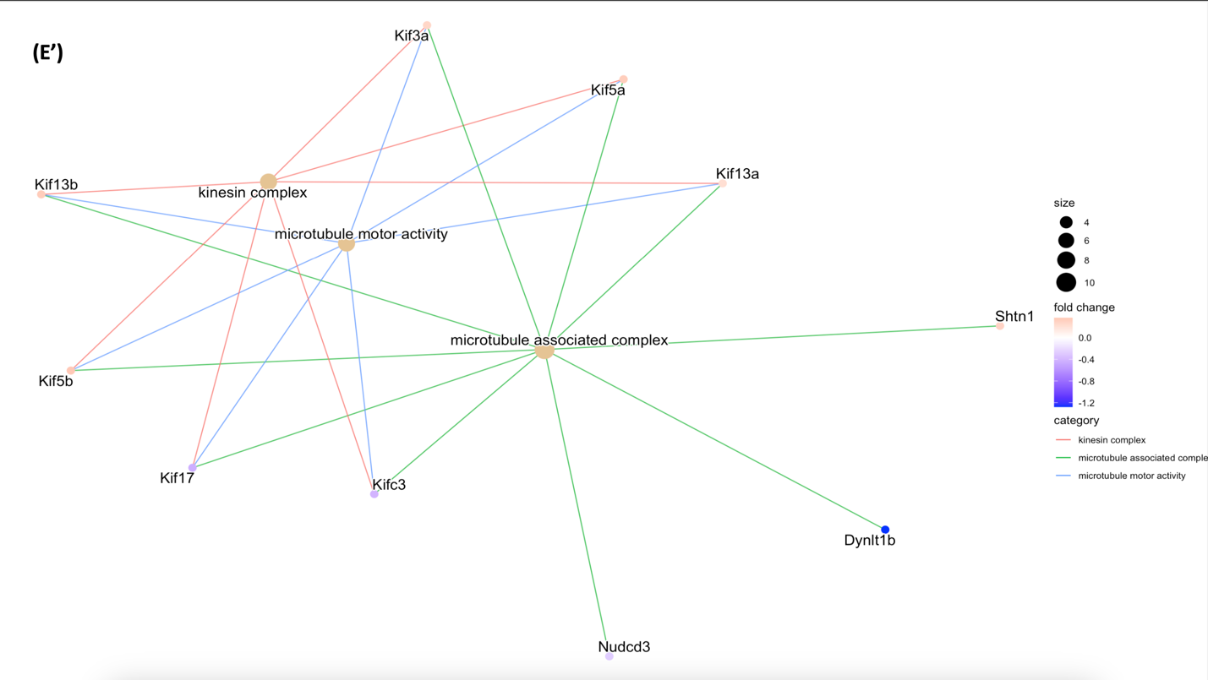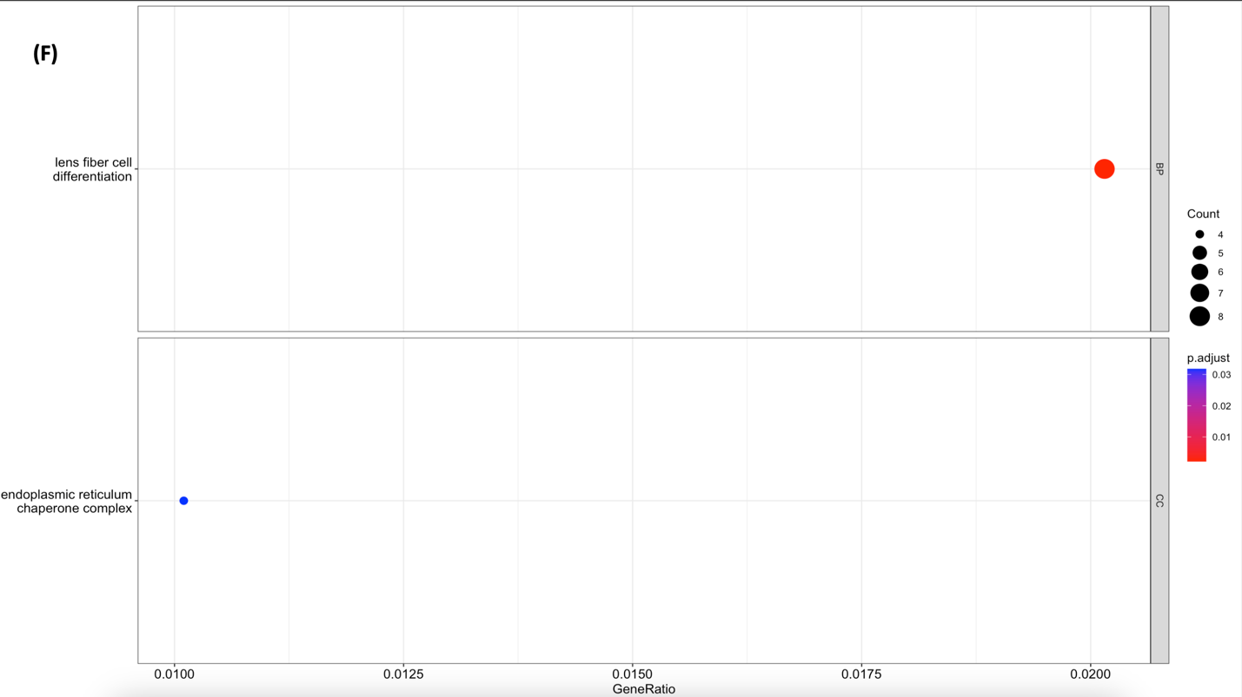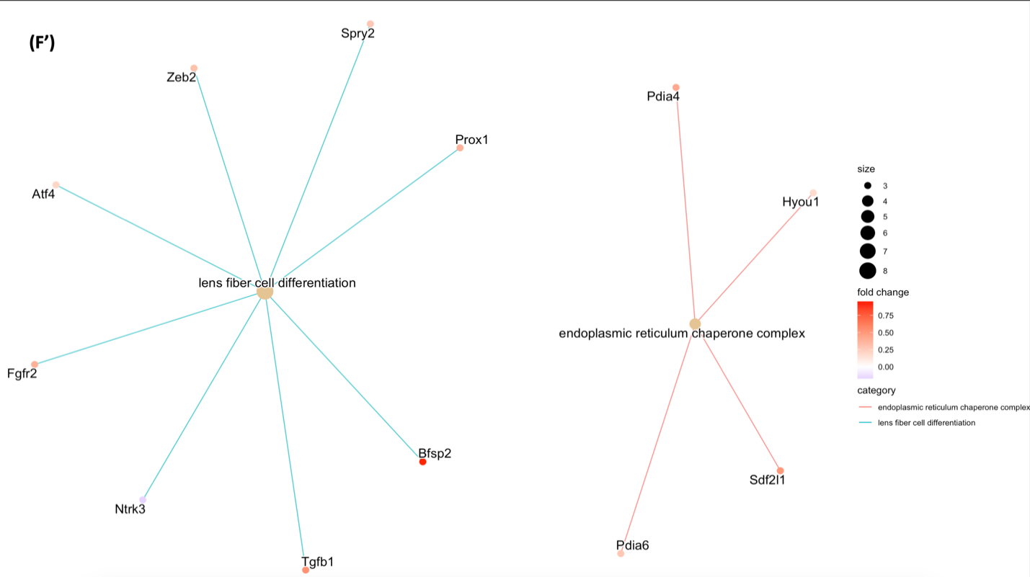

**Figure 3. Visual Representation of gene ontology enrichment analysis of WT and *mdx* mice in different age groups.**

Geno Ontology (GO) Enrichment Analysis find statically significant (p<0.05) biological processes (BP), molecular functions (MF), and cellular components (CC) that were different in the medulla and cervical spinal cord tissues of the *mdx* and WT mice. Above is the GO analysis of (A, A’) p8 medulla, (B, B’) 6 month medulla, (C, C’) 12 month medulla, (D, D’) p8 cervical spinal cord, (E, E’) 6 month cervical spinal cord, (F, F’) 12 month cervical spinal cord of wild type (n = 9) and *mdx*(n = 10). The analysis gave no results for 12 month medulla, so there is no graph representation present above. The left column representation of the results are dotplots showing at a max 5 of the significant processes found. The right column representation of the results are catplots showing a max of 3 of the significant processes (out of all three possible processes) found with gene names mapped to the different processes. The color of the gene circles corresponds to their fold change difference between *mdx* and WT mice.

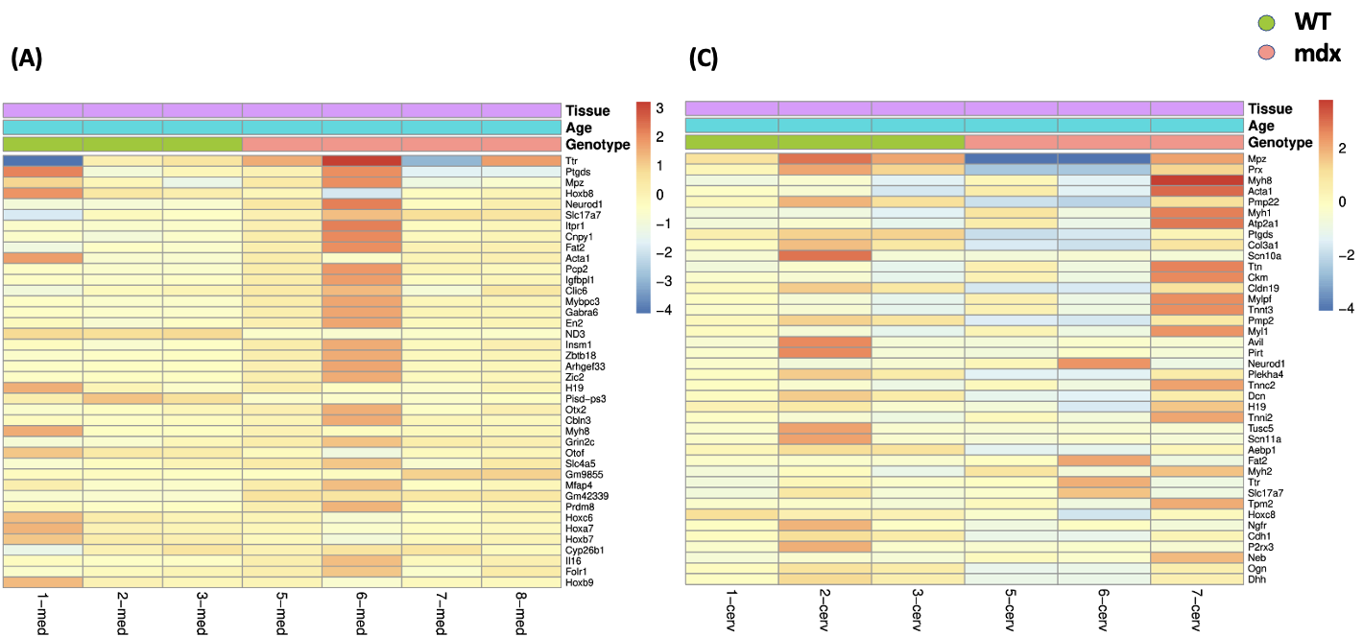

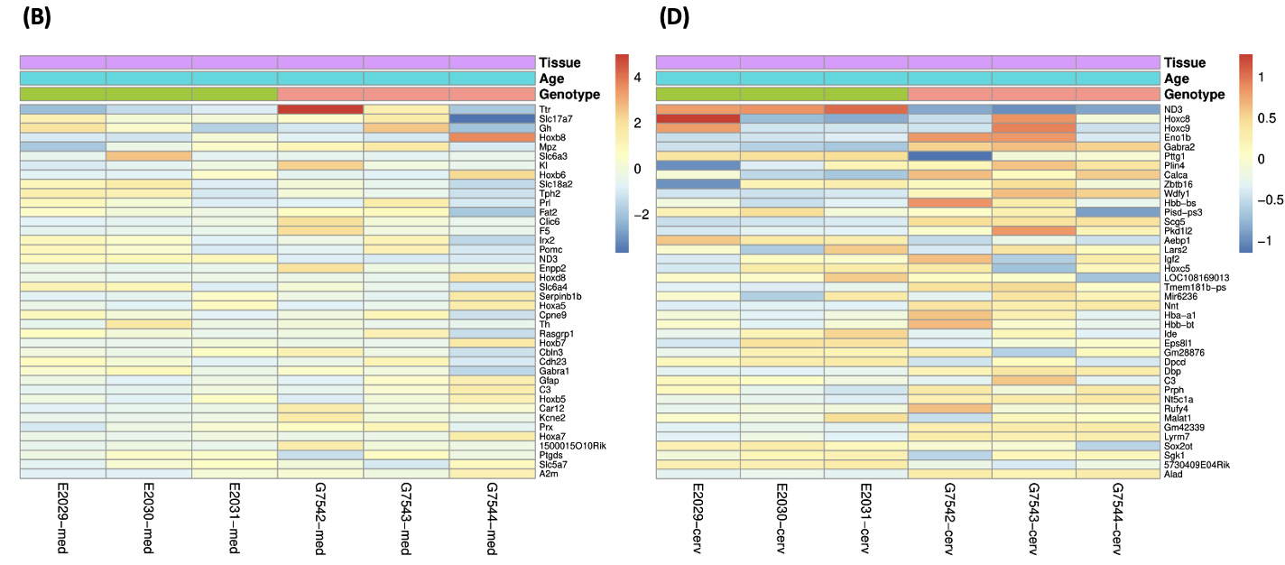

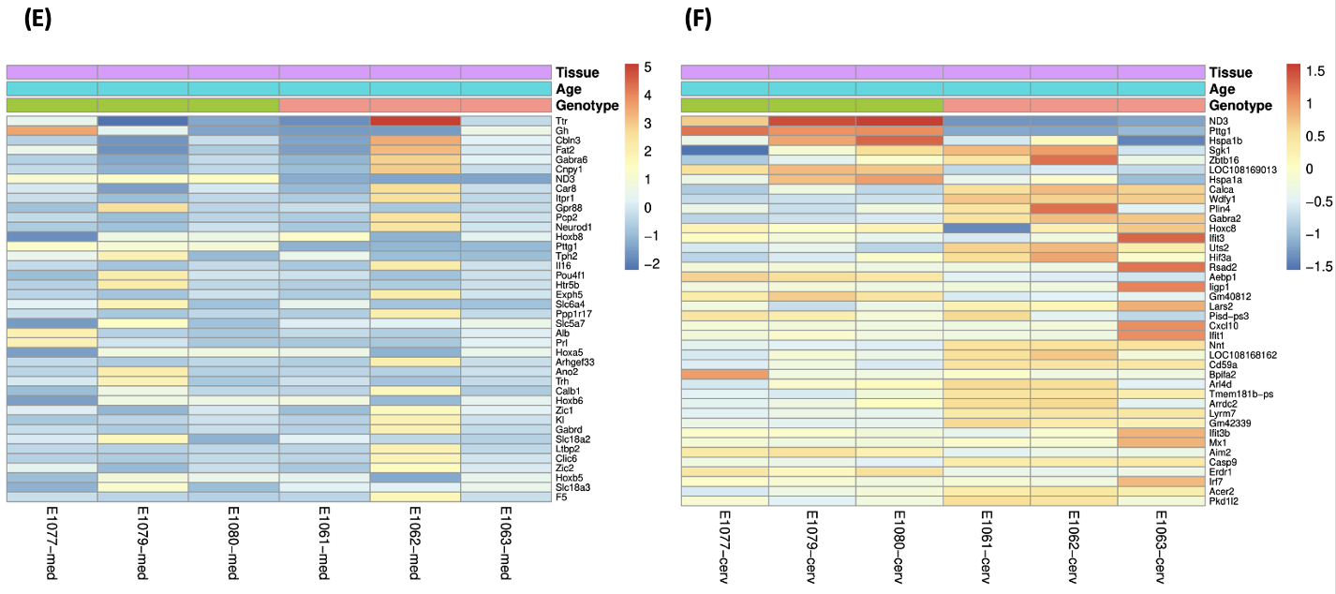

**Figure 4. Heat Maps of gene expression data of WT and *mdx* mice in different age groups**

Heat plots after variance stabilizing transformation of the matrix for overall gene expression and differential expression analysis of (A) p8 medulla, (B) 6-month medulla, (C) 12 month medulla, (D) p8 cervical spinal cord, (E) 6 month cervical spinal cord, (F) 12 month cervical spinal cord of wild type (n = 9) and *mdx*(n = 10). These plots show the WT mice as the green genotype and the *mdx* mice as the cream color. The darker red the gene, the more upregulated it is and the darker blue the gene, the more downregulated it is. The heatmaps show the 40 most significant genes. These plots give a more holistic understanding of the differences in expression as the mice age.

**References**

Baydun, A., Gilgoff, I., Prentice, W., Carlson, M., & Fischer, D. A. (1990). Decline in Respiratory Function and Experience with Long-Term Assisted Ventilation in Advanced Duchenne’s Muscular Dystrophy. *Chest*, *97*(4), 884–889. https://doi.org/10.1378/chest.97.4.884

Davis, J. N. (1967). Phrenic nerve conduction in man. *Journal of Neurology, Neurosurgery, and Psychiatry*, *30*(5), 420–426.

Dhindsa, J. S., McCall, A. L., Strickland, L. M., Fusco, A. F., Kahn, A. F., & ElMallah, M. K. (2020). Motor axonopathies in a mouse model of Duchenne muscular dystrophy. *Scientific Reports*, *10*(1), Article 1. https://doi.org/10.1038/s41598-020-65824-1

Ervasti, J. M., Ohlendieck, K., Kahl, S. D., Gaver, M. G., & Campbell, K. P. (1990). Deficiency of a glycoprotein component of the dystrophin complex in dystrophic muscle. *Nature*, *345*(6273), Article 6273. https://doi.org/10.1038/345315a0

*Gm16867 predicted gene, 16867 [Mus musculus (house mouse)]—Gene—NCBI*. (n.d.). Retrieved April 17, 2023, from https://www.ncbi.nlm.nih.gov/gene/100862085

Jin, E.-H., Sung, J. K., Lee, S.-I., & Hong, J. H. (2018). Mitochondrial NADH Dehydrogenase Subunit 3 (MTND3) Polymorphisms are Associated with Gastric Cancer Susceptibility. *International Journal of Medical Sciences*, *15*(12), 1329–1333. https://doi.org/10.7150/ijms.26881

Jonckheere, A. I., Smeitink, J. A. M., & Rodenburg, R. J. T. (2012). Mitochondrial ATP synthase: Architecture, function and pathology. *Journal of Inherited Metabolic Disease*, *35*(2), 211–225. https://doi.org/10.1007/s10545-011-9382-9

Kohler, M., Clarenbach, C. F., Bahler, C., Brack, T., Russi, E. W., & Bloch, K. E. (2009). Disability and survival in Duchenne muscular dystrophy. *Journal of Neurology, Neurosurgery & Psychiatry*, *80*(3), 320–325. https://doi.org/10.1136/jnnp.2007.141721

Lin, H. C., & Barkhaus, P. E. (2009). Cranial Nerve XII: The Hypoglossal Nerve. *Seminars in Neurology*, *29*(1), 45–52. https://doi.org/10.1055/s-0028-1124022

Love, M., Ahlmann-Eltze, C., Forbes, K., Anders, S., Huber, W., FP7, R. E., NHGRI, N., & CZI. (2023). *DESeq2: Differential gene expression analysis based on the negative binomial distribution* (1.38.3). Bioconductor version: Release (3.16). https://doi.org/10.18129/B9.bioc.DESeq2

Mauro, A. L., & Aliverti, A. (2016). Physiology of respiratory disturbances in muscular dystrophies. *Breathe*, *12*(4), 318–327. https://doi.org/10.1183/20734735.012716

Mercuri, E., Bönnemann, C. G., & Muntoni, F. (2019). Muscular dystrophies. *The Lancet*, *394*(10213), 2025–2038. https://doi.org/10.1016/S0140-6736(19)32910-1

*Mgp matrix Gla protein [Mus musculus (house mouse)]—Gene—NCBI*. (n.d.). Retrieved April 26, 2023, from https://www.ncbi.nlm.nih.gov/gene/17313

Pangalila, R. F., van den Bos, G. A., Bartels, B., Bergen, M., Stam, H. J., & Roebroeck, M. E. (2015). Prevalence of Fatigue, Pain, and Affective Disorders in Adults With Duchenne Muscular Dystrophy and Their Associations With Quality of Life. *Archives of Physical Medicine and Rehabilitation*, *96*(7), 1242–1247. https://doi.org/10.1016/j.apmr.2015.02.012

Sicinski, P., Geng, Y., Ryder-Cook, A. S., Barnard, E. A., Darlison, M. G., & Barnard, P. J. (1989). The Molecular Basis of Muscular Dystrophy in the mdx Mouse: A Point Mutation. *Science*, *244*(4912), 1578–1580. https://doi.org/10.1126/science.2662404

*SLC25A37 solute carrier family 25 member 37 [Homo sapiens (human)]—Gene—NCBI*. (n.d.). Retrieved April 17, 2023, from https://www.ncbi.nlm.nih.gov/gene/51312

*TTR transthyretin [Homo sapiens (human)]—Gene—NCBI*. (n.d.). Retrieved April 26, 2023, from https://www.ncbi.nlm.nih.gov/gene/7276